KL04 - KL04 Delete Activity types

Functionality
You want to delete an activity type which was created wrongly. This transaction enables you to delete an activity type master data.

Scenario
This transaction is used to delete activity types where there are no dependant records.

Requirements

Activity master data exists. No dependant records exist.

Menu Path | Accounting → Controlling → Cost Center Accounting → Master Data → KL04 - Delete
Transaction Code | KL04

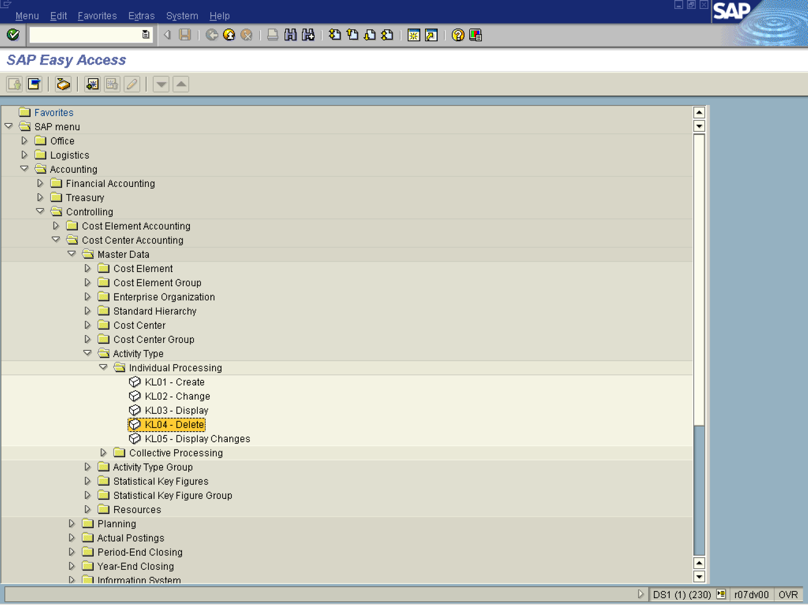

1. Double Click on KL04 - Delete

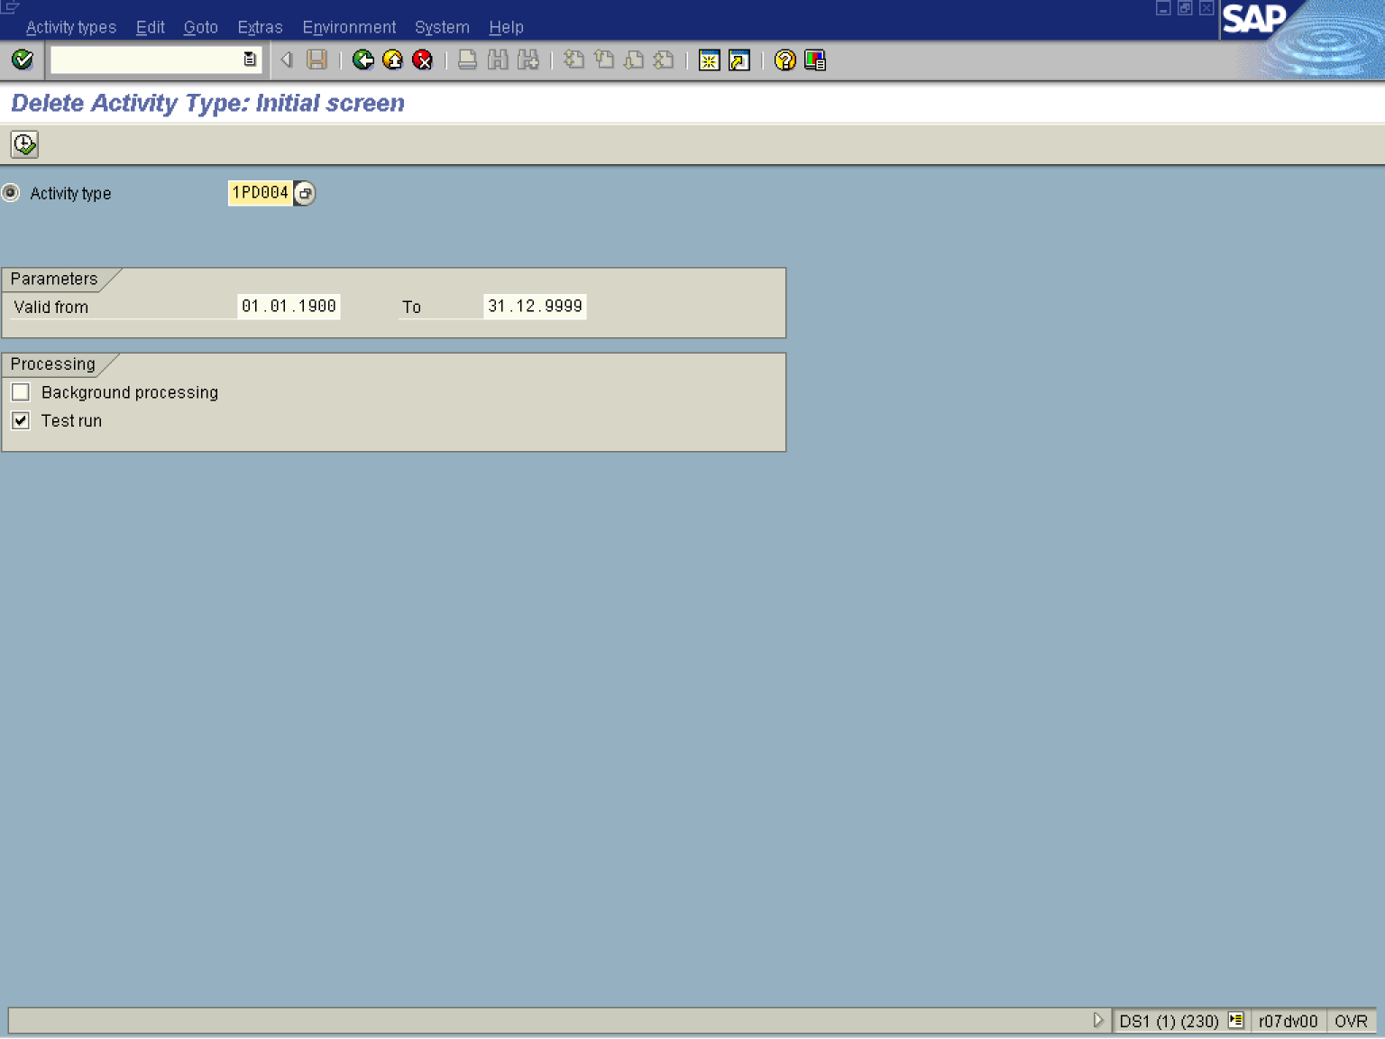

2. Update the following fields:

Field Name | Field Description | Values
Activity Type | Enter the activity number | Example: 1PD004

3. Click Execute

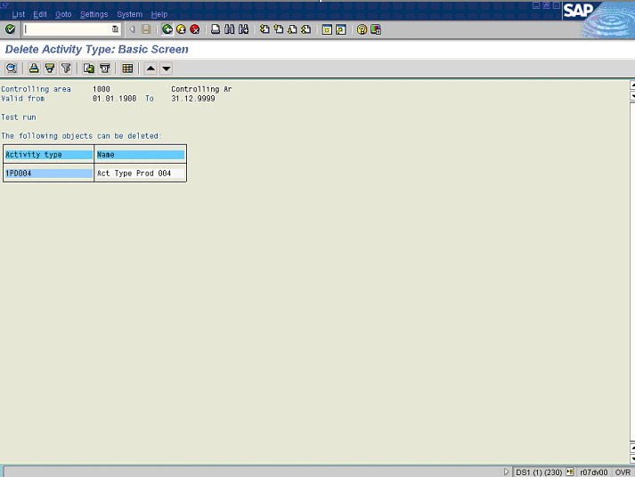

Note: A status of a test deletion of the activity type is displayed.
4. Click Back

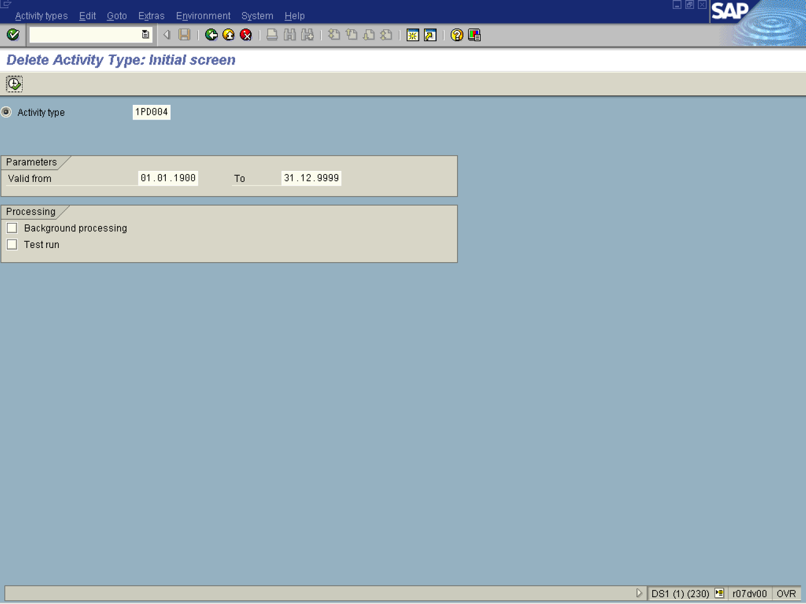

5. Click <checkbox> Test run .
Note: This option controls whether or not a test run takes place.
If Test run is active, the system only generates a log. Data is neither updated nor changed in the database.
If Test run is not activated, the system updates data in the database..

6. Click Execute

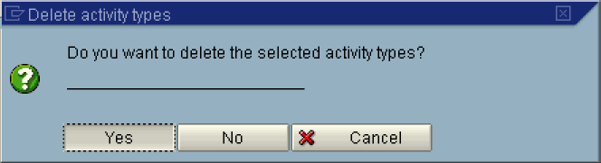
7. Click Yes .

